
Potree Treasure Hunt
Kaibab
- How wide is the canyon? *Distance Measurement 

- Reduce the number of points so visualization speeds increase. 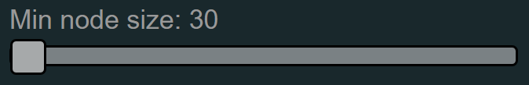

Utah
- How tall is the capitol building? *Height Measurement 

- Find a yellow car parked by the capitol building. 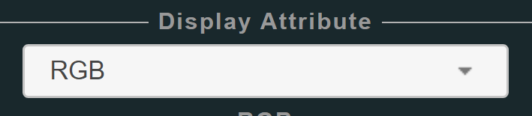

- Make everything purple except the top of the capitol building is blue with a green tip (hint: use elevation). 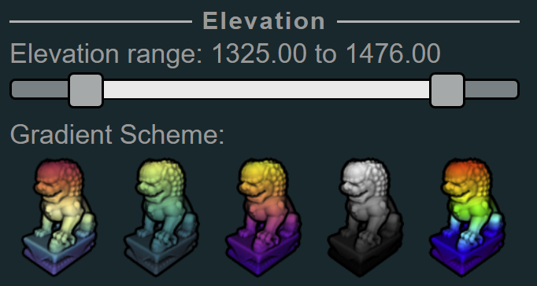

Granite Dells
- How wide is the dam? *Distance Measurement

- Plot a topographic profile directly behind the dam. *Height Profile

Boulder
- Remove vegetation in the mountains and in town. 

- What is the area of the field at the stadium? *Area Measurement

- What are the angles between the centers of the 3 stadium buildings? *Angle Measurement

