Potree Treasure Hunt

Kaibab
- How wide is the canyon?
Tools > Distance Measurement > ~3,400m
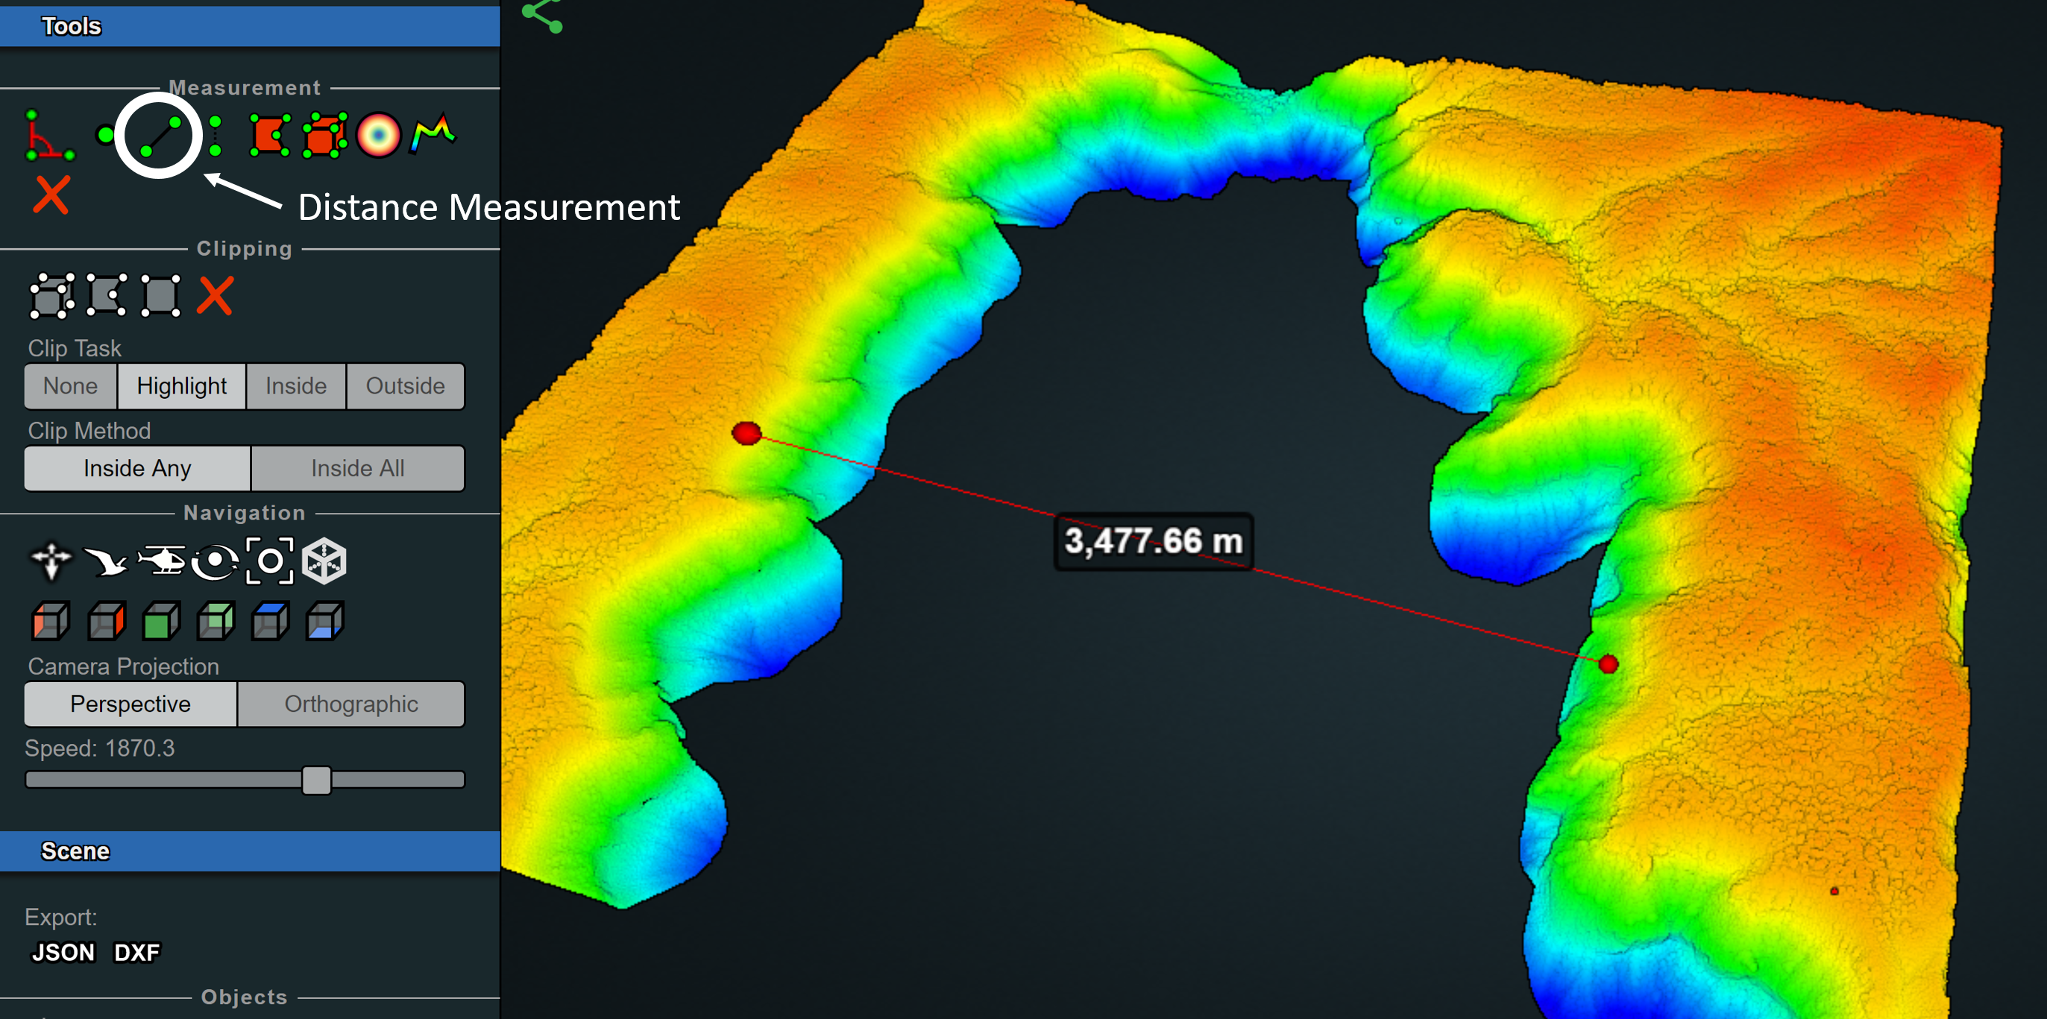

- Reduce the points so visualization speeds increase.
Appearance > Min node size
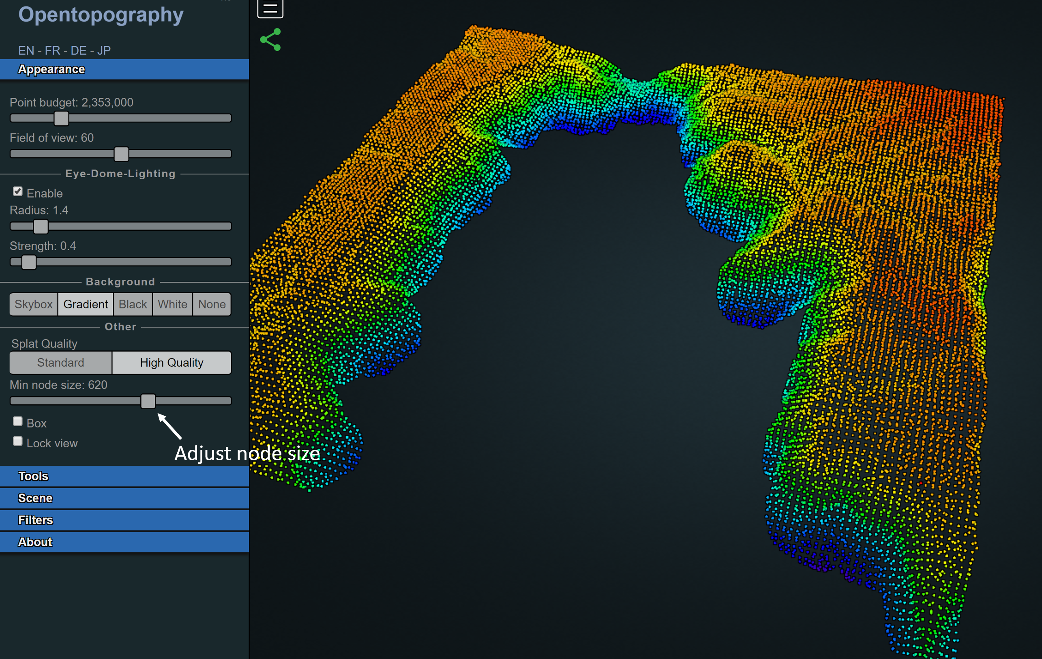

Utah
- How tall is the capitol building?
Tools > Height Measurement > ~80m
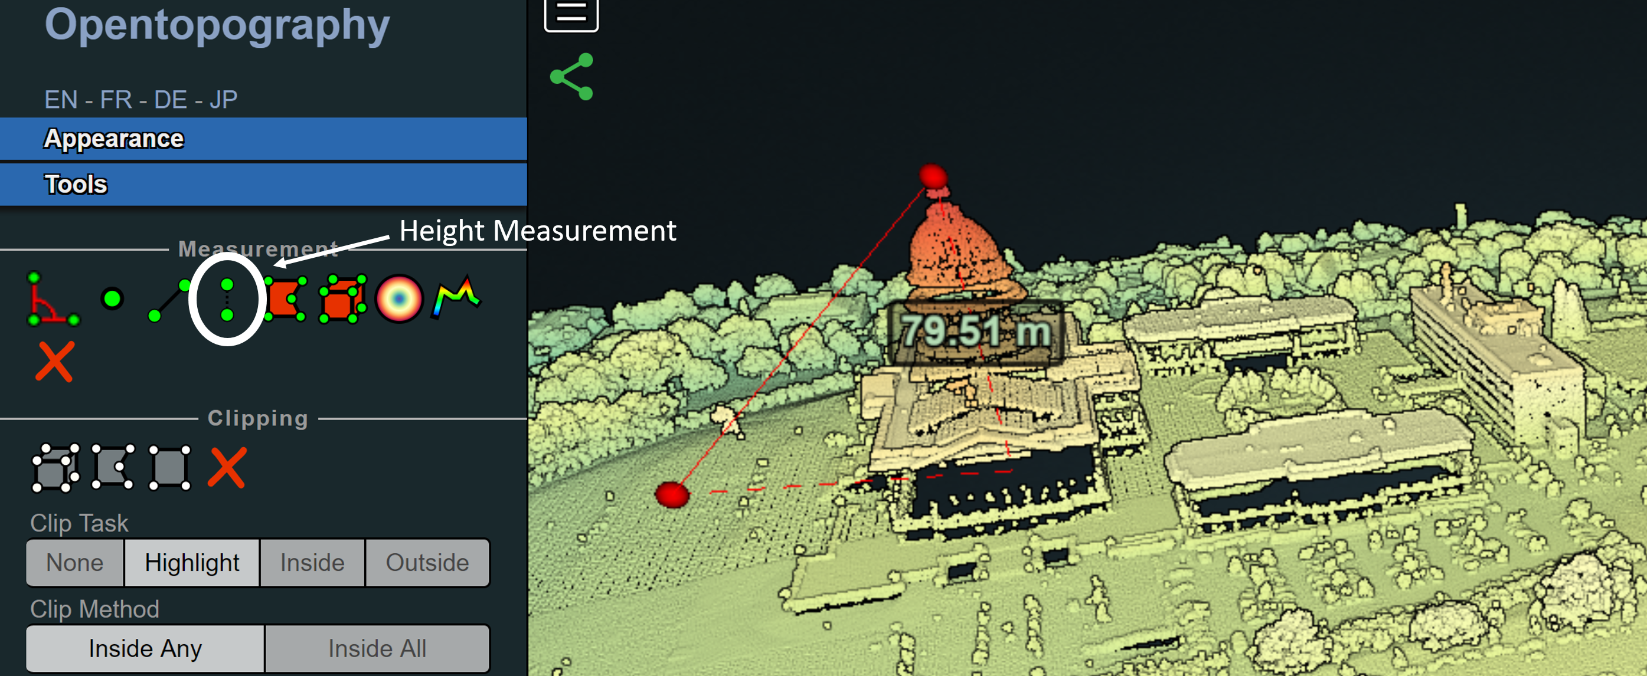

- Find a yellow car parked by the capitol building.
Scene > Display attribute > RGB
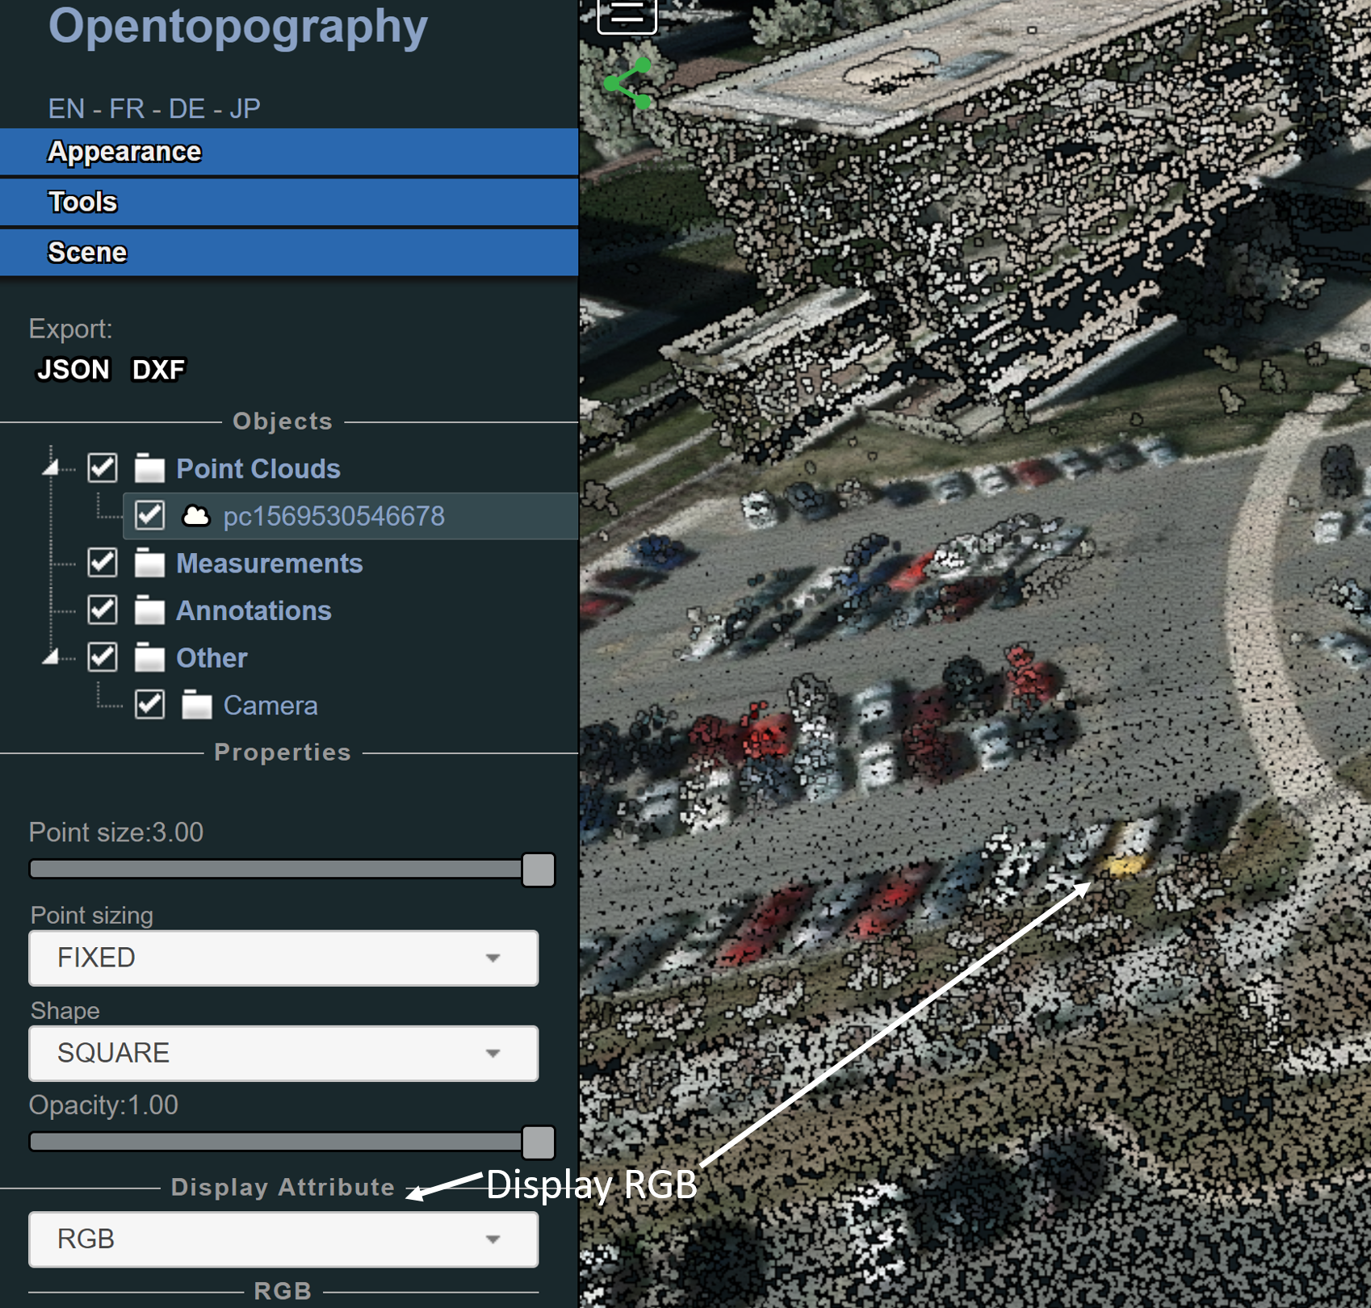

- Make everything purple except the top of the capitol building is blue with a green tip. (hint: use elevation)
Scene > Elevation > Gradient Scheme > adjust range
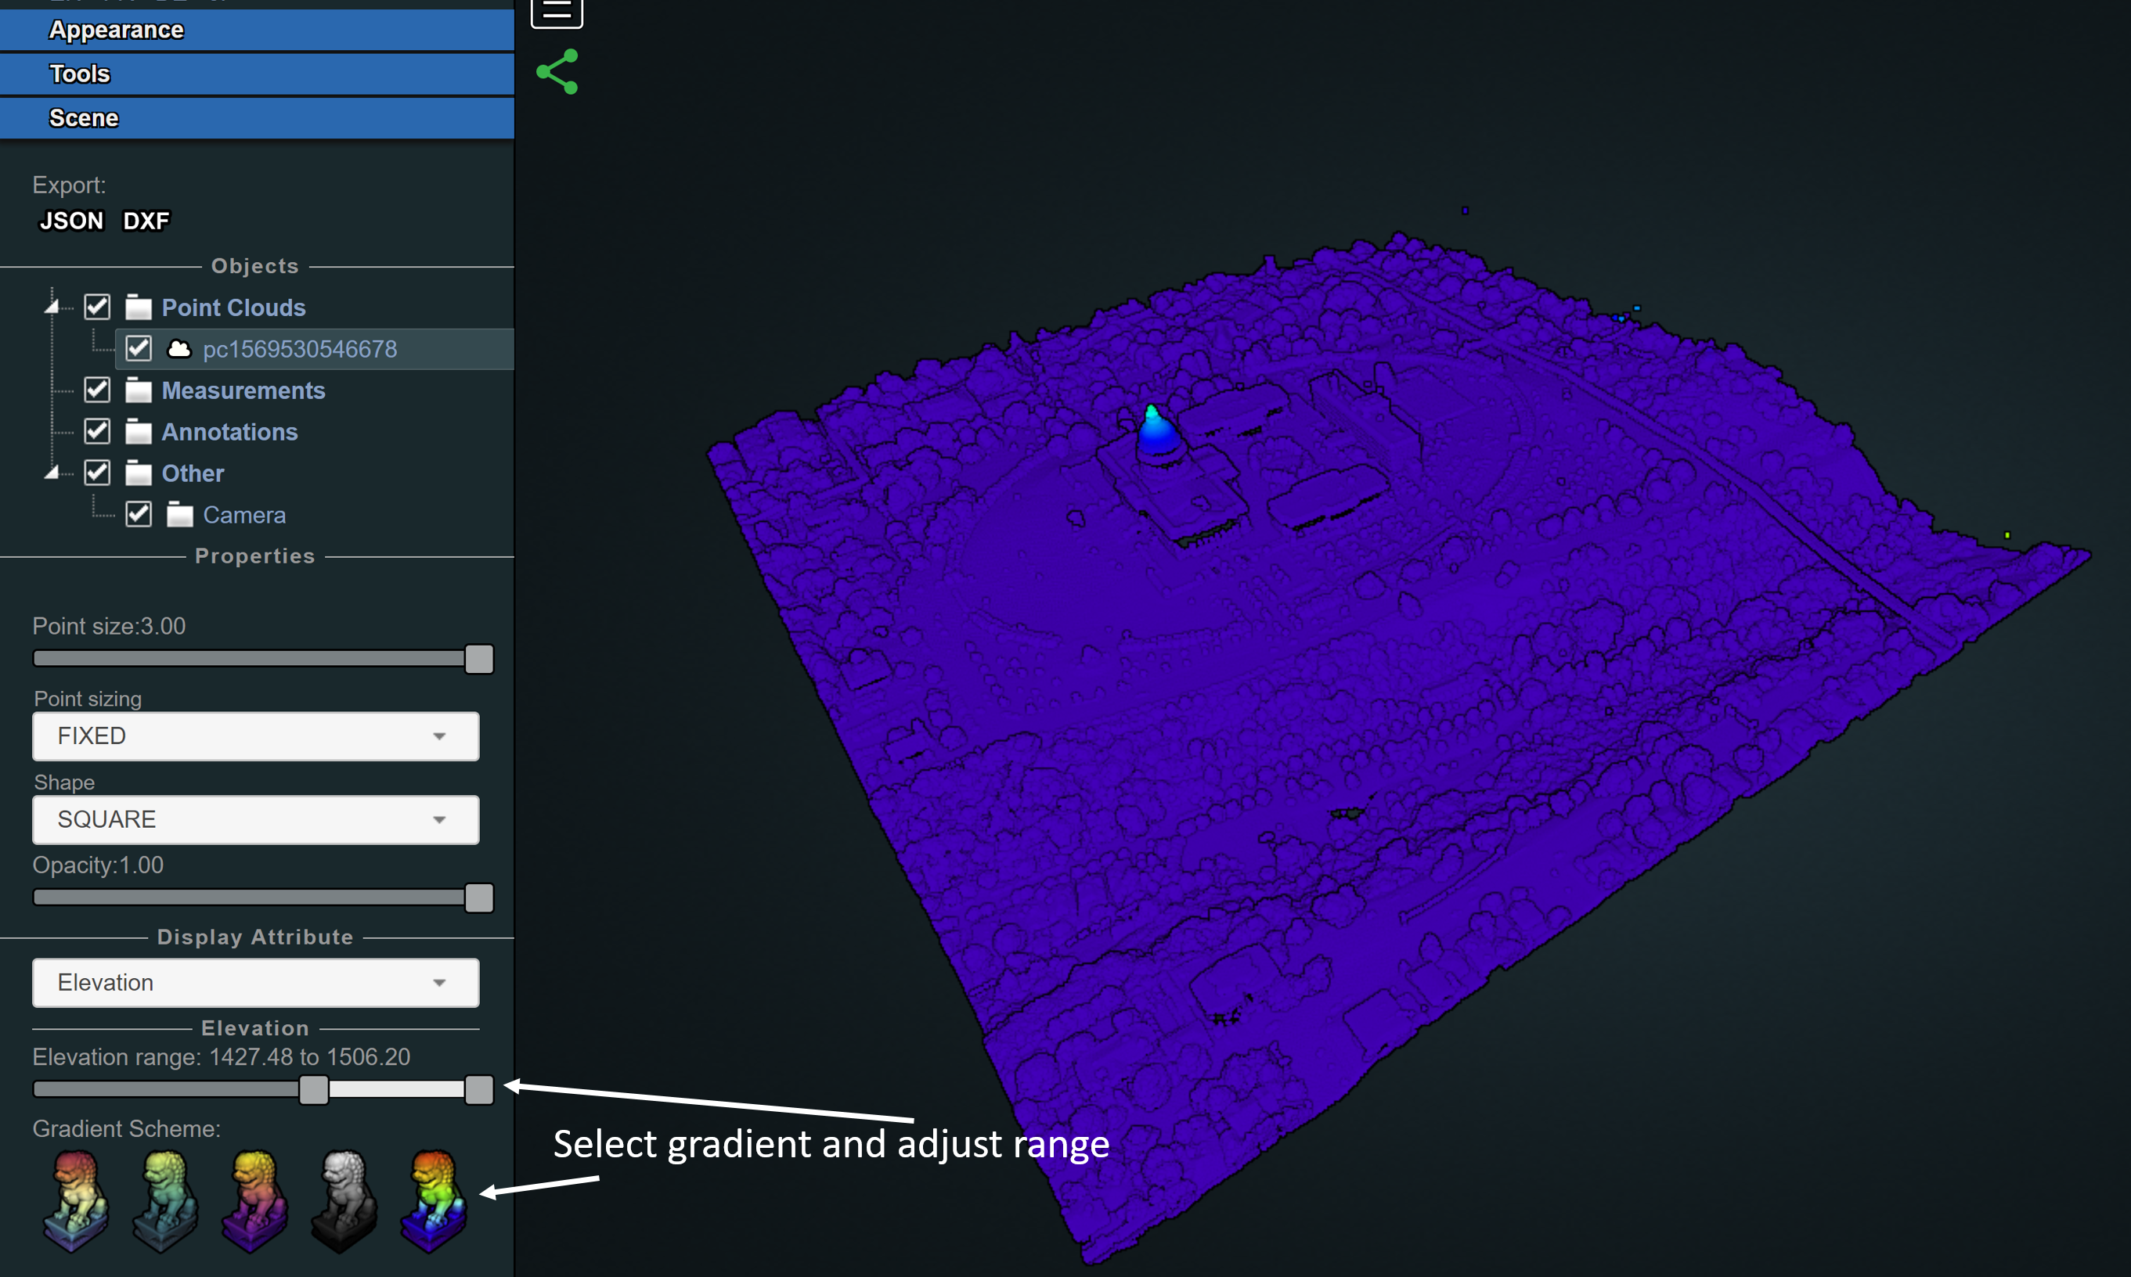

Granite Dells
- How wide is the dam?
Tools > Distance Measurement > ~75m
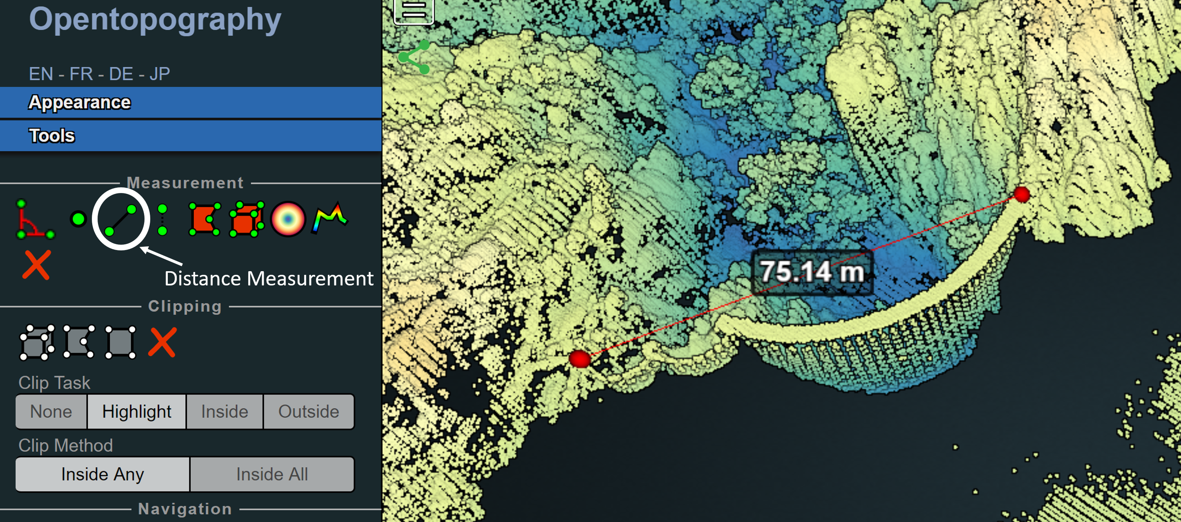

- Plot a topographic profile directly behind the dam.
Tools > Height profile, Scene > Show 2D profile
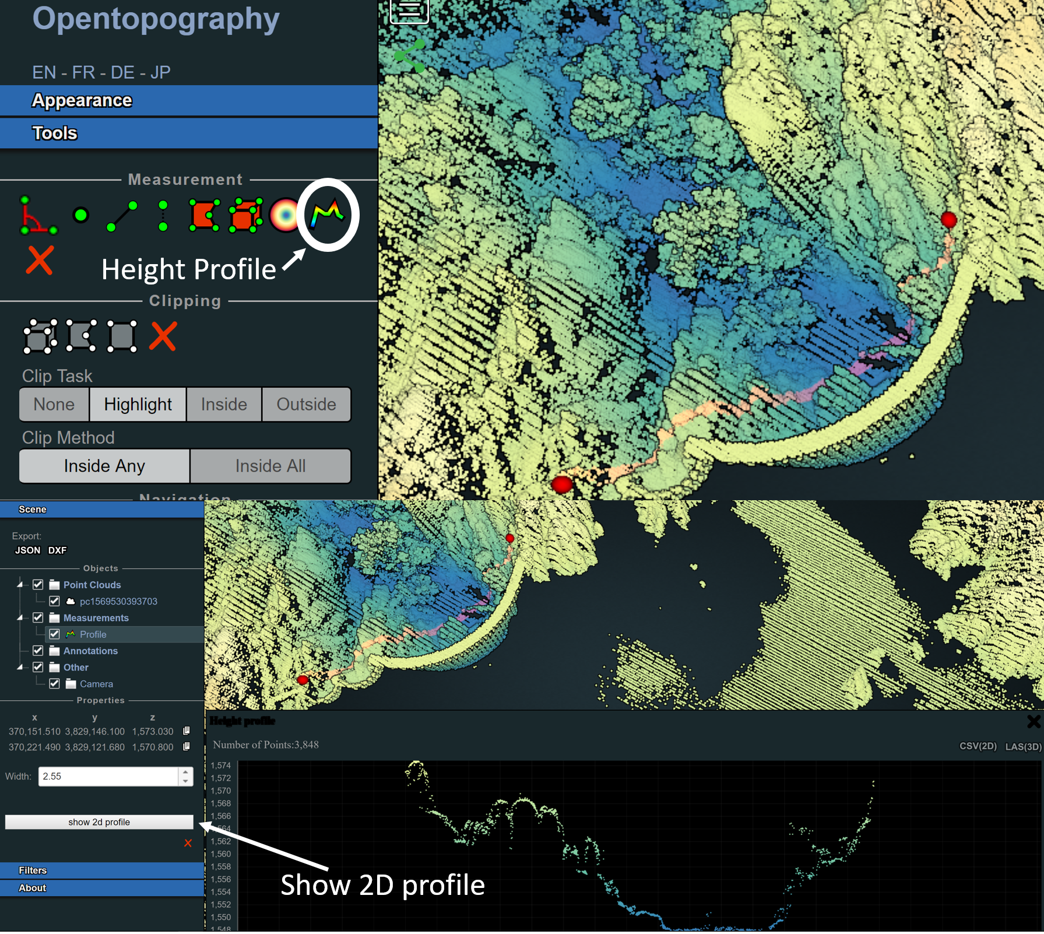

Boulder
- Remove the vegetation in the mountains and in town.
Filters > Classification
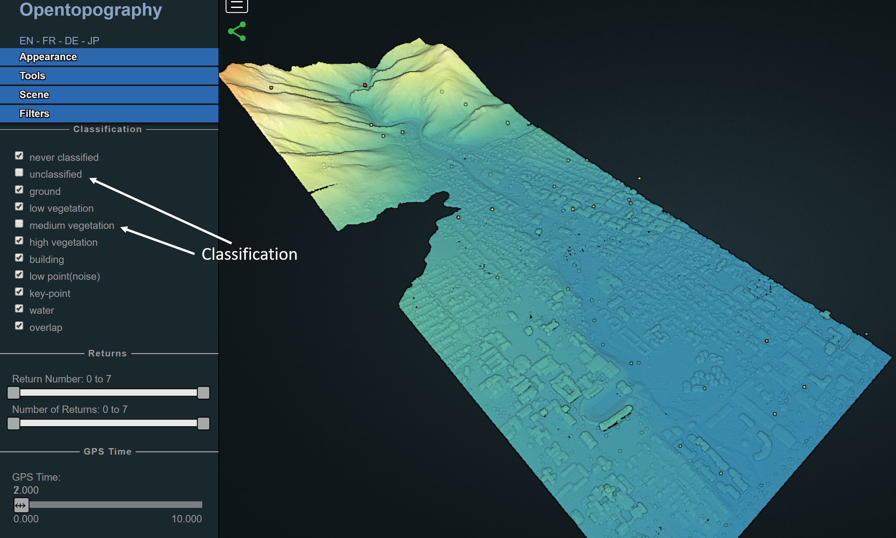

- What is the area of the field at the stadium?
Tools > Area Measurement > ~7,200m²
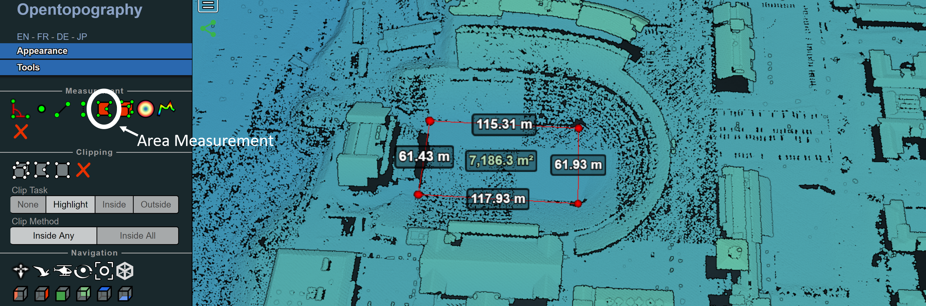

- What are the angles between the centers of the 3 stadium buildings?
Tools > Angle Measurement > ~45°, 80°, 55°
