Measuring Fold Orientation in Painted Canyon near the San Andreas Fault

By Chelsea Scott & Ramon Arrowsmith

Introduction:
The Southern San Andreas Fault is a right-lateral strike-slip fault that accommodates the relative motion between the Pacific and North American tectonic plates. The Painted Canyon site is in the Mecca Hills, located on the northeastern side of the San Andreas Fault 10 km north of the Salton Sea (Figure 1). The site is well-known for its structural geology—The faults in the shear zone form a classic flower structure or palm-tree geometry. The San Andreas and the Painted Canyon Faults (Figure 2) dip steeply at depth but flatten towards the surface as they form low angle thrust faults, mimicking the leaves of a palm tree (See Figure 2 in the field guide by Sylvester and Smith, 1986). This geometry reflects transpressive strike-slip faulting (Sylvester and Smith, 1976; Bergh et al., 2019). Between the two faults, the sedimentary rocks are folded, resulting in folds with a variety of geometries.

In this exercise, you are provided with a point cloud collected by an uncrewed aerial vehicle (UAV) or drone. This point cloud samples a fold located adjacent to the Painted Canyon fault that is part of the Palm Springs unit. You asked to make a measurements of limb orientation along the fold and conduct a structural analysis of the fold using the compass tool in CloudCompare (Thiele et al. 2017). The assignment asks you to consider the fold orientation in context with the San Andreas Fault.

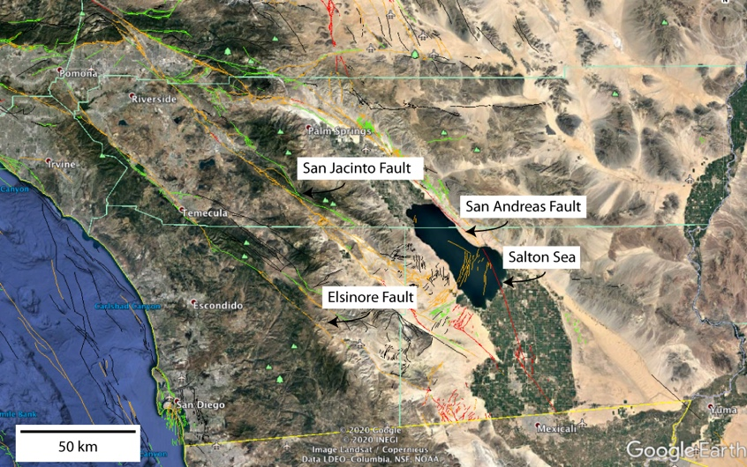
Figure 1: Map of southern California showing the USGS database of Quaternary faults.

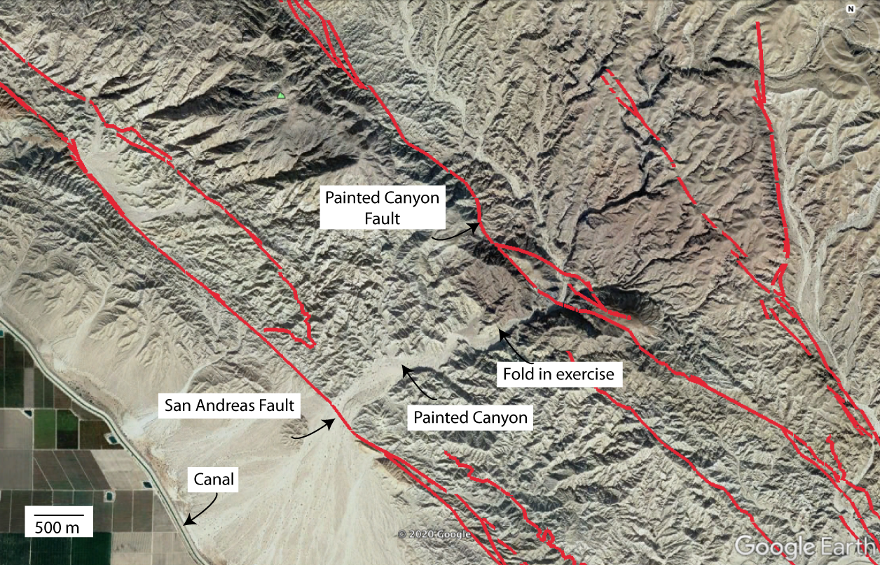Figure 2: Zoom to Painted Canyon showing the location of the San Andreas Fault and the fold in this exercise.

1. (20 points) Make measurements of bedding orientation along the fold in the Painted_canyon_fault.laz file using Cloud Compare. Measure_Orientations_CloudCompare.docx outlines the steps for measuring orientations from a point cloud.
Be sure to measure both limbs. You should make 150-200 measurements. Turn in the csv file that you export from CloudCompare.

2. (20 points) Use Stereonet (http://www.geo.cornell.edu/geology/faculty/RWA/programs/stereonet.html) to do the following:
a) Plot planes and poles to the measured bedding orientations. Describe your data in a 2-3 sentences.

b) Contour the poles: What is the approximate orientation of both fold limbs?

c) Perform a cylindrical best-fit of the poles to the planes: What is the orientation (trend and plunge) of the hinge line?

d) Pick axial plane: (Hint: be careful about selecting the acute vs. the obtuse angle.)
What is the approximate dip of the axial plane?

e) Name the fold type using the dip of the axial surface and the plunge of the hinge line terminology.
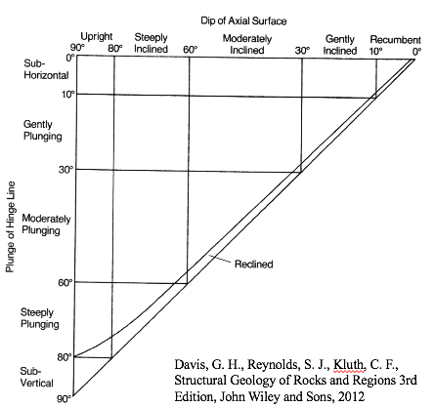

3. (20 points) Estimate the orientations of the maximum and minimum principal strains. Relate the shortening to the San Andreas Fault. Draw a sketch. Is the fold orientation consistent with your expectations? Why or why not?

4. (10 points) Estimate the amount of shortening accommodated by the fold. What is the strain rate?
Hint: Use the distance measurement tool in Cloud Compare. What two lengths are needed to estimate the shortening? And, you should assume the deformation occurred after the deposition of the overlying Ocotillo Formation at 0.76 Ma.

Acknowledgements: Scott was supported by the US National Science Foundation Postdoctoral Fellowship 1625221 and by the School of Earth and Space Exploration at Arizona State University. Scott thanks Sarah Titus for first introducing her to Painted Canyon during a Carleton College field trip.

References:

Painted Canyon:

Bergh, S.G., Sylvester, A.G., Damte, A., and Indrevær, K., 2019, Polyphase kinematic history of transpression along the Mecca Hills segment of the San Andreas fault, southern California: Geosphere, v. 15, p. 901–934, doi:10.1130/GES02027.1.
Sylvester, A.G., and Smith, R.R., 1976, Tectonic Transpression and Basement-Controlled Deformation in San Andreas Fault Zone, Salton Trough, California: AAPG Bulletin, v. 60, doi:10.1306/C1EA3A73-16C9-11D7-8645000102C1865D.
Sylvester, A.G., and Smith, R.R., 1986, Structure section in Painted Canyon, Mecca Hills, southern California: Centennial Field Guide Volume 1 - Cordilleran Section: Geological Society of America, v. Chapter 24, p. 103–108.
Sylvester, A.G., 1988, Strike-slip faults: Bulletin of the Geological Society of America, doi:10.1130/0016-7606(1988)100<1666:SSF>2.3.CO;2.

Cloud Compare Measurement Tool:

Thiele, S.T., Grose, L., Samsu, A., Micklethwaite, S., Vollgger, S.A., and Cruden, A.R., 2017, Rapid, semi-automatic fracture and contact mapping for point clouds, images and geophysical data: Solid Earth, v. 8, p. 1241–1253, doi:10.5194/se-8-1241-2017.

