Measuring Bedding Orientations in CloudCompare

This document outlines how to make measurements of bedding orientations using CloudCompare from a point cloud dataset.

- Download CloudCompare: CloudCompare software. The software is open source and works on Mac, Windows, and Linux OS. We recommend downloading the most recent stable version of the software (i.e., not beta) available for your operating system (http://www.danielgm.net/cc/release/).

For Mac, open the dmg file and then click the Cloud Compare icon. A warning message saying that the application was downloaded from the internet may open. It is okay to open Cloud Compare. If you still cannot open Cloud Compare, you may have to go to System Preferences-> Security and Privacy-> Allow apps downloaded from: App store and identified developers. These instructions may change for future Mac OS. In this case, the solution is likely easily searchable on Google.

**There have been some important changes to the Compass Plugin so we recommend that you download the most recent version of CloudCompare. **

- Open the point cloud in CloudCompare.

File -> Open Files -> Select the las or laz point cloud file -> Yes to all questions asked when loading in the datasets.
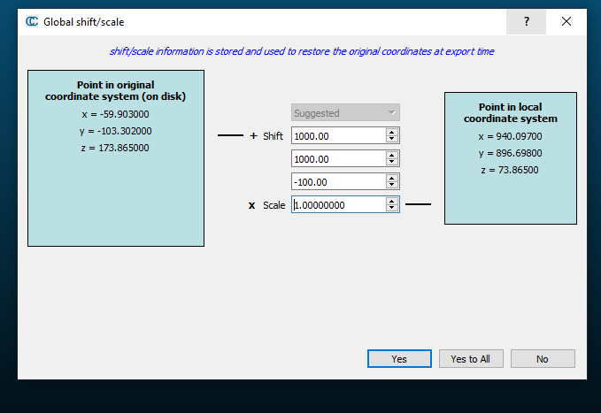

- Explore the point cloud.

Left click: Rotate the point cloud; Right click: shift the point cloud. When the point cloud is shifted, the center of rotation remains at the center of the screen.

The point size can be changed by the point size option on the left side of the screen. Make sure you have the point cloud selected in the upper left. When zooming in, it is often helpful to make the point size larger.
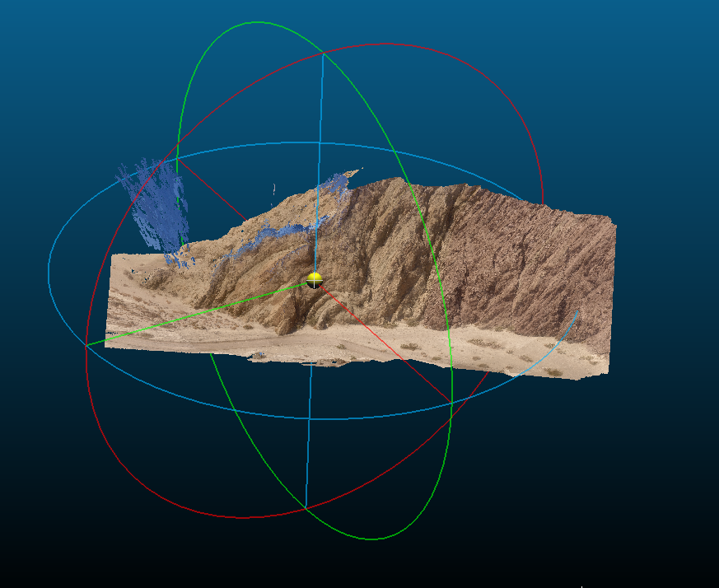

- Open the Compass Plugin from the Plugin window. Find and click on the Plane tool in the Compass toolbar.

- Make measurements of bedding orientation: Place the red circle over the set of points that form a plane (such as a portion of a fold limb) that you would like to measure. You can change the size of the red circle by zooming in or out. When you click, CloudCompare will solve for the best-fitting plane to those points. When the points are well-fit by a plane, your measurement will be recorded. CloudCompare will plot a plane and the pole to that plane. Don’t worry when the normal vector is plotted beneath the surface.

Make each measurement with care. Is the red compass tool over an area that you would measure in the field? If not, then the area is not a good place to make a measurement. Clicking somewhat at random will not result in quality measurements. Using this measurement tool and the point cloud is likely to speed up field measurements particularly in areas that are difficult to access. Care is still needed to measure meaningful features.

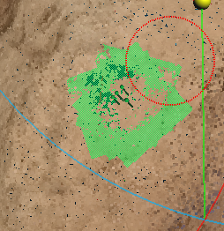

- It will be helpful to take a dense set of measurements. It is also important to measure both limbs of the fold, even though one limb is better exposed. 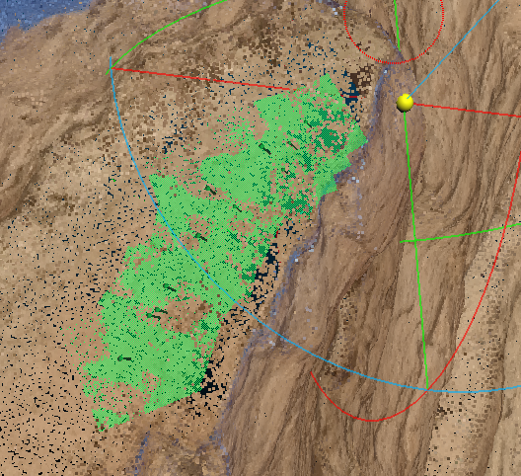

- Export the measurements as a csv file by clicking on the save button.

- To measure the length of lines (for example to learn about the scale of the georeferenced point cloud and to calculate strain): 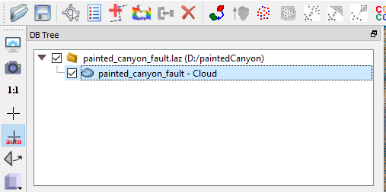

Check that the point cloud is selected. Then select the cross-hairs tool.

This will measure the length between any two points in the point cloud.

- Download Stereonet from Prof. Allmendinger. http://www.geo.cornell.edu/geology/faculty/RWA/programs/stereonet.html

- Guidance on Stereonet is available here: http://www.geo.cornell.edu/geology/faculty/RWA/programs/stereonet-help.pdf

Resources:

Wikipedia page for CloudCompare:
https://www.cloudcompare.org/doc/wiki/index.php?title=Compass_(plugin)

Compass tool:
Thiele, S. T., Grose, L., Samsu, A., Micklethwaite, S., Vollgger, S. A., and Cruden, A. R.: Rapid, semi-automatic fracture and contact mapping for point clouds, images and geophysical data, Solid Earth, 8, 1241–1253, https://doi.org/10.5194/se-8-1241-2017, 2017.

