OpenTopography

Topographic differencing: Earthquake along the Wasatch fault

Learning objectives:

- Visualize how earthquakes permanently deform landscapes
- Describe the relationship between fault slip, surface displacement, and earthquake magnitude
- Interpret quantitative geospatial datasets
- Learn Cloud Compare skills: load data, scissors, point picker, fine point cloud alignment
- Practice teamwork and scientific writing skills

Introduction:
An earthquake occurred last night along the Wasatch Fault in Salt Lake City. You are a geologist working for the United States Geological Survey (USGS). You are asked to map the surface rupture and calculate the surface displacement, coseismic slip, and earthquake magnitude to characterize the surface damage.

Topographic differencing is a technique used to estimate 3D surface displacements from high-resolution topographic imagery acquired before and after an earthquake. You are provided with a pre- earthquake lidar (light detection and ranging) point cloud that was acquired by the state of Utah in 2013-2014. The “post-earthquake” imagery in Figure 4 mimics the lidar imagery that would be acquired in the days to weeks following a major earthquake. You will use Cloud Compare Software to calculate surface displacements from these two datasets.

Available data:
- Shaded relief map showing the surface rupture (Figure 4)
- Pre- and post- earthquake high resolution topography point cloud .las files. Select the pre- and post- .las file from one of the three available tiles. The small tile can be helpful if doing this exercise on a laptop computer.
- Surface displacement profiles (Figure 5)
- Far-field vertical coseismic displacement field (Figure 6)

Your assignment is write a short report to the USGS with the following information:
- A map and a description of the surface rupture
- At least three displacement measurements on both the hanging wall and the footwall
- Fault slip magnitude
- Earthquake moment magnitude. Hint: Use Figure 6 in the calculation
- Discussion that answers the following questions:
  - Comment on the measured displacements. Are all handing wall displacements identical? What about the footwall? Why or why not?
  - Are the hanging wall and footwall displacements equal? What does this suggest?
  - What are the sources of error in the surface displacement measurements?

Background:
Fault geometry and Earthquake magnitude:
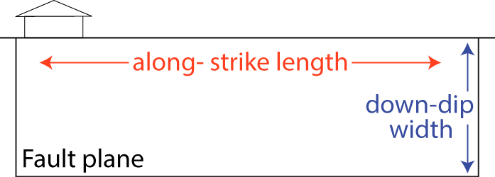
Figure 1: Schematic image of a fault plane showing geometric faults terms.

Earthquake moment ($M_{o}$) is calculated from the along-strike fault length ($L$), down-dip fault width ($w$), and coseismic fault slip ($s$):
$M_{o}=μLws$. | (1)
$μ$ is the shear modulus equal to 32 GPa, and Moment magnitude ($M_{w}$) is:
$M_{w}=\frac{2}{3}(\log_{10}(M_{o})$-9.1), | (2)
Where $M_{o}$ has units of Newton meters.

Surface slip: The shape and magnitude of the surface deformation field depend on the fault geometry (strike and dip), sense of slip (rake), and the amount of fault slip.

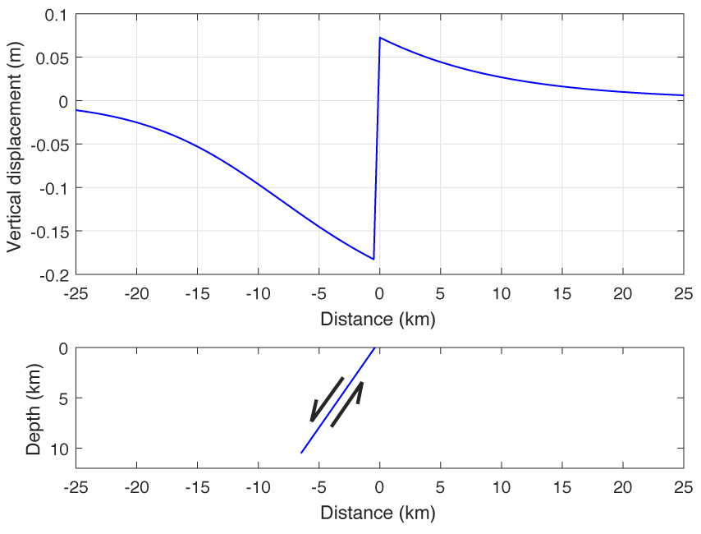
Figure 2: Top: Vertical surface displacement produced by 30 cm of slip on a 60° dipping normal fault. Bottom: Fault geometry that produced the displacement profile in the top figure. Does the displacement field extend beyond the fault plane?

3D displacements:
3D coseismic surface displacements are calculated from pre- and post- earthquake high resolution topography using the Iterative Closest Point (ICP) algorithm as shown in Figure 3 (Besl and McKay, 1992; Chen and Medioni, 1992; Nissen et al. 2012).

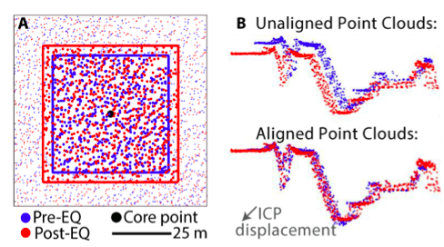

Figure 3: Outline of the Iterative Closest Point (ICP) algorithm used to calculate 3D surface displacements. (A) Select subsets of the pre- earthquake (blue) and post- earthquake (red) point clouds. (B) Calculate the 3D rigid deformation (rotation and displacement) that produces the best alignment between the two point clouds.

Vectors, matrices, and matrix multiplication are used to describe rotations and displacements mathematically. We can apply a rotation and translation (i.e., displacement) to the pre- earthquake point cloud (${PC}_{pre}$) and produce a point cloud (${PC}_{pre}^{deformed}$) that describes the Earth’s topography after the earthquake:
$${PC}_{pre}^{deformed}=\left(\begin{matrix}1 & -γ & β \\ γ & 1 & -α \\ -β & α & 1\end{matrix}\right){PC}_{pre}+\left(\begin{matrix}t_{x} \\ t_{y} \\ t_{z}\end{matrix}\right).$$ | (3)
$α$, $β$, and$γ$ are rotations about the $x$, $y$ and $z$ axes, and $t_{x}$, $t_{y}$ and $t_{z}$ are translations in the $x$, $y$ and $z$ directions. The rotation and displacement are commonly described succinctly as:
$$\left(\begin{matrix}\begin{matrix}1 & -γ \\ γ & 1\end{matrix} & \begin{matrix} β & t_{x} \\ -α & t_{y}\end{matrix} \\ \begin{matrix}-β & α \\ 0 & 0\end{matrix} & \begin{matrix}1 & { t}_{z} \\ 0 & 1\end{matrix}\end{matrix}\right).$$ | (4)
References:
Besl, P. J., and N. D. McKay (1992), A method for registration of 3-D shapes, IEEE Trans. Pattern Anal. Mach. Intell., 14(2), 239–256, doi:10.1109/34.121791.
Chen, Y., and G. Medioni (1992), Object modelling by registration of multiple range images, Image Vis. Comput., 10(3), 145–155, doi:10.1016/0262-8856(92)90066-C.
Nissen, E., Krishnan, A. K., Arrowsmith, J. R., & Saripalli, S. (2012). Three-dimensional surface displacements and rotations from differencing pre- and post-earthquake LiDAR point clouds. Geophysical Research Letters, 39(16). https://doi.org/10.1029/2012GL052460

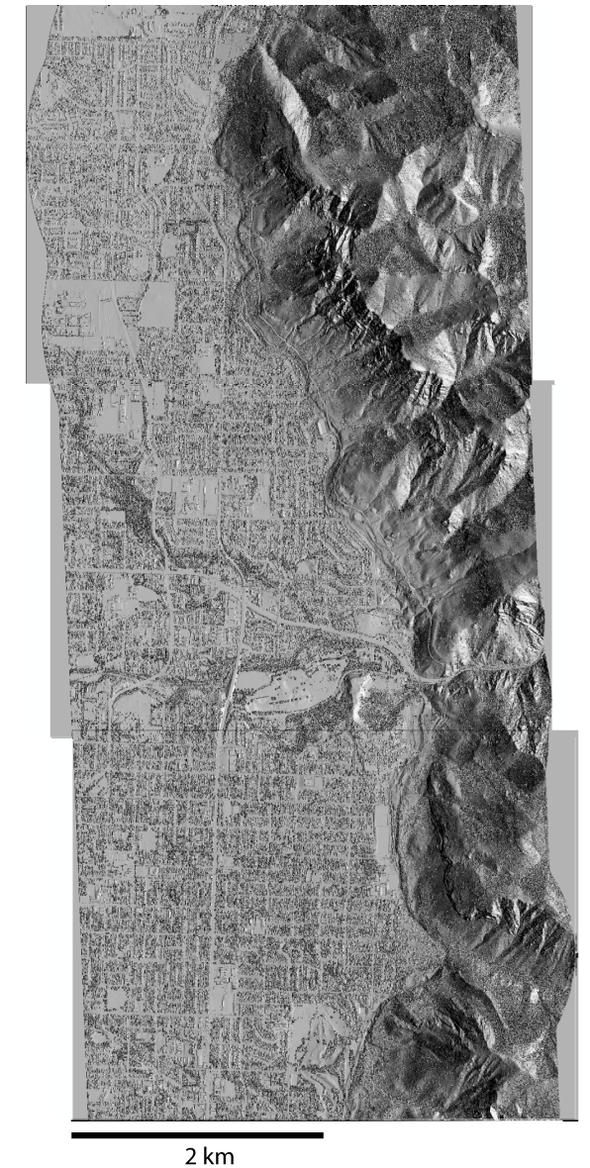
Figure 4: Shaded relief post-earthquake imagery showing a portion of the surface rupture. Trace the surface rupture. Note this imagery does not span the full earthquake. Use arrows to draw horizontal displacements on the map. Use an open circle to denote upward motion and a closed circle to denote downward motion.

Distance from fault (km) | East-west displ. (m) | North-south displ. (m) | Vertical displ. (m) | Quality estimate
Table 1: Record your surface displacement measurements. In the ‘distance from fault’ column, negative distances correspond to measurements on the hanging wall (west of the fault), and positive distances correspond to measurements on the footwall (east of the fault).

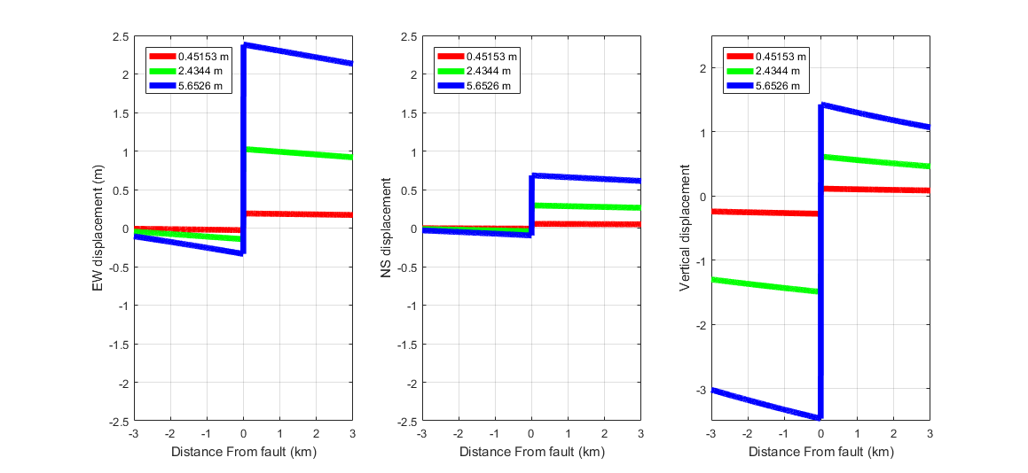

Figure 5: Surface displacement profiles produced by 0.45 m (red), 2.43 m (green), and 5.62 m (blue) of fault slip on a 60° dipping normal fault. Plot your surface displacement vs. distance from fault measurements on the profiles to estimate the amount of surface slip. Hint: The vertical displacement estimate is the most reliable.
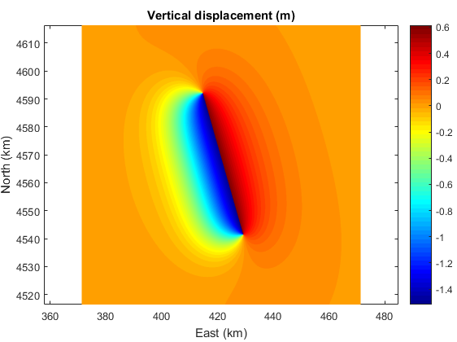
Figure 6: Vertical surface displacement in meters. Estimate the fault area for the magnitude calculation. Refer to Figure 2 to estimate the rupture width.

